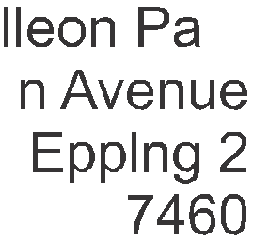

INDEMNITY FORM

RE: GOODS STORED AT LEOPARD MOVERS (PTY) LTD

Neither Leopard Movers (Pty) Ltd nor its stuff will be held accountable for damages to goods that we store if they are not wrapped

Clients should ensure that they have arranged appropriate insurance for the goods as Leopard Movers (Pty) Ltd does not offer insurance for goods that we store

Packing & Wrapping Costs

- Buff tape R15each
- Bubble wrapping R20 per metre (Leopard Movers doing the wrapping)
- Bubble wrap R450 for 100m roll (Client doing own wrapping)
- Boxes R30 each (Client doing own packing)
- Supply of box + packing material R75 each (Leopard Movers doing the packing)
- Hanger boxes R375 each
-Plastic covers (1 double bed size) R60each
- Plastic covers (1 Queen bed size) R100each

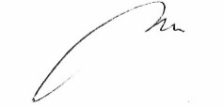
……………………………
Kudzai Charles Mandaza
For and behalf of Leopard Movers (Pty) Ltd Client

Date: 10 August 2019 Date 10 August 2019

